COOPERATION TO STRENGHTEN THE CITIZENS’ MATH SKILLS IN THE CONTEXT OF SUSTAINABLE DEVELOPMENT

SAGATAVOŠANAS VIZĪTE  AD-2012_1 b-32124  11/2012-03/2012 | Partneri:  ●VILNIUS GABRIELE PETKEVICAITE-BITE ADULT EDUCATION CENTRE (LT)  ●NGO INNOVA ESTONIA (EE)  ●Izglītības inovāciju pārneses centrs  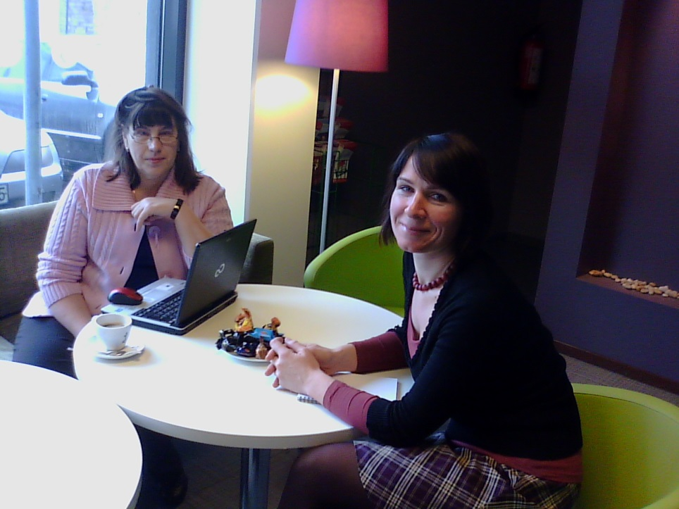
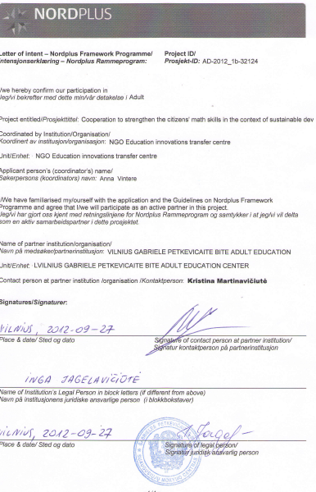
Rezultāts
Sagatavots projekta pieteikums
SADARBĪBA IEDZĪVOTĀJU MATEMĀTIKAS PRASMJU SEKMĒŠANAI ILGTSPĒJĪGAS ATTĪSTĪBAS UN LABKLĀJĪBAS KONTEKSTĀ

