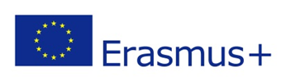
STRATEGIC PARTNERSHIP
LANGUAGE LEARNING FOR „SCREEN“ GENERATION
No. 2014-1 -LV01-KA201 -000467

Kick off meeting
2014-12-11 - 2014-12-14

Date | Activity | Outcomes
11 December 2014 | Arrival day of the partners
12 December | The partners were met at the hotel lobby and welcomed at Kedainiai Language School, where we had a presentation of each institution, mingled with each other. Later the project coordinator presented and informed about administrational and management requirements while conducting the project. In the afternoon the project partners had a guided tour in Kedainiai and a common dinner with a cultural event. | Well organized project management
13 December 2014 | All the partners expressed their expectations shared the responsibilities of the future project activities see annex 1 | Project website  Facebook group  Videos  Well administrated project documents
13 December 2014 | The second part of the day was focused on a Seminar held by Kedainiai Language Teachers and project team work, the aim of the seminar was to share the experience of the methods used in Kedainiai Language School to motivate the pupils while teaching a language. The methods may widely be used worldwide and are supposed to be included in the toolkit of the project. | Shared experience  Collected methods
14 December 2014 | Departure day

