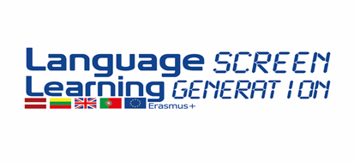
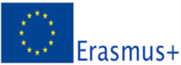
PORTUGAL PROGRAMME
3rd MEETING
17th – 19th APRIL , 2016
No. 2014-1 -LV01-KA201 -000467

Day 1 - 16 April
Arrival

Check in Hotel at Ibis Hotel

Day 2 – 17 April
9.00am (all day) | Cultural Visit to Porto (free choise)

Day 3 -18 April
10.00 -12.00 | Group Work meeting
11.00 -11.30 | Coffee Break : traditional Goods from the countries
15.00 -18.00 | Visit to Braga
20.30 | Welcoming dinner

Day 4 – 19 April
10.00am  (1st part)  10.30am  11.00am | Seminar: “Learning languages by Technologies Methods” at the auditorium of André Soares school by:  1st part: by Lia Raquel Oliveira, Phd, Department of Curricular Studies and Educational Technology - Education Institute University of Minho;  Coffee Break  2nd part: interactive workshop by Adelina Moura Foreigner Language Teacher of a Secondary Carlos Amarante
13.00pm | Lunch
15.00pm  18.00pm | Visit to Braga
20.30pm | Dinner (Farewell)

Day 5 – 20 April
10.00am | Work meeting:  meeting evaluation report  Latvia: last meeting agenda  Certificates of attendance ceremony

20th April /21st -Departure

Hotel information:
IBIS Hotel: http://www.accorhotels.com/gb/hotel-9042-ibis-budget-braga-centro/index.shtml
prices 36,00€ /including breakfast
Latvia-2 persons + 2 companions/ Standard double (single use)- (Check in 17^{th /} check out 21st)
Lithuania – 2 persons 1 Standard double (double use) (check in 17th/check out 19th/04)
UK – 2 persons/ Standard double (single use) (check in 17th / 21st check out)
PS: please confirm

Recommended transports Airport - Braga – Braga-airport:
GET BUS http://www.getbus.eu/index.php?lang=en&seccao=2
By Train: https://www.cp.pt/passageiros/en/

Contacts:
Maria Veloso: +351917624042
Hélder Carvalho: + 351933230290
Bragamob: +351253054659

Portugal - April , 7Th, 2016

